**10Pontos.txt**

[5, 8, 4, 2, 7, 10, 3, 6, 9, 1, 5] = 2505

Tempo = 0s

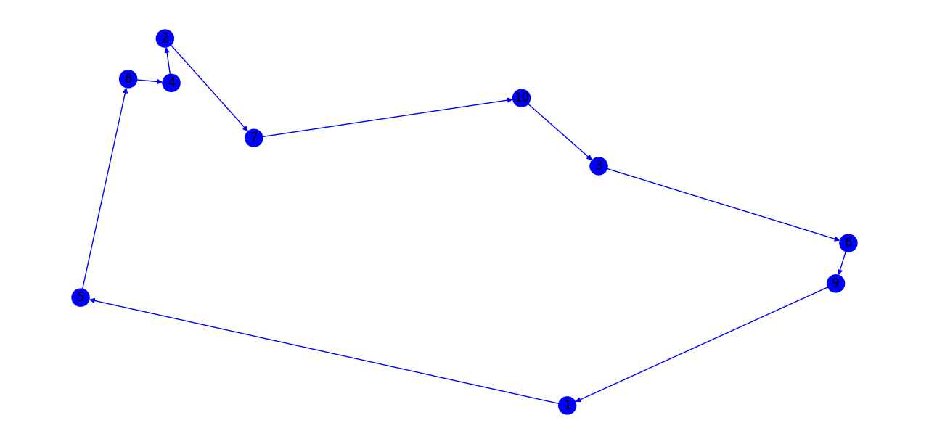

**12Pontos.txt**

[5, 4, 1, 9, 2, 11, 10, 3, 7, 12, 6, 8, 5] = 3336

Tempo = 0s

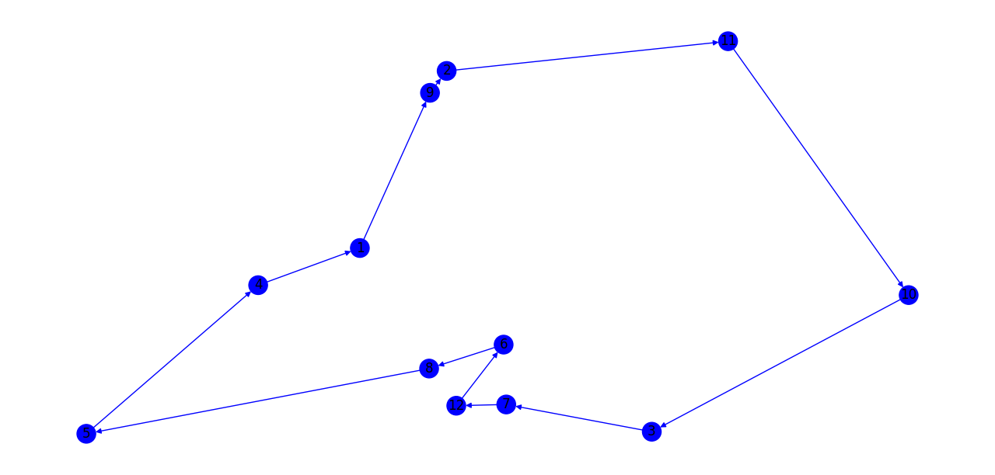

**15Pontos.txt**

[4, 5, 8, 14, 2, 7, 10, 3, 11, 13, 9, 12, 15, 1, 6, 4] = 4110

Tempo = 0s

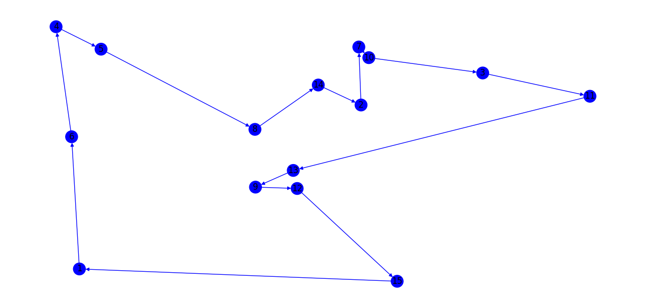

**20Pontos.txt**

[7, 1, 3, 6, 13, 16, 8, 4, 19, 11, 9, 12, 17, 14, 20, 18, 2, 5, 10, 15, 7] = 3594

Tempo = 0s

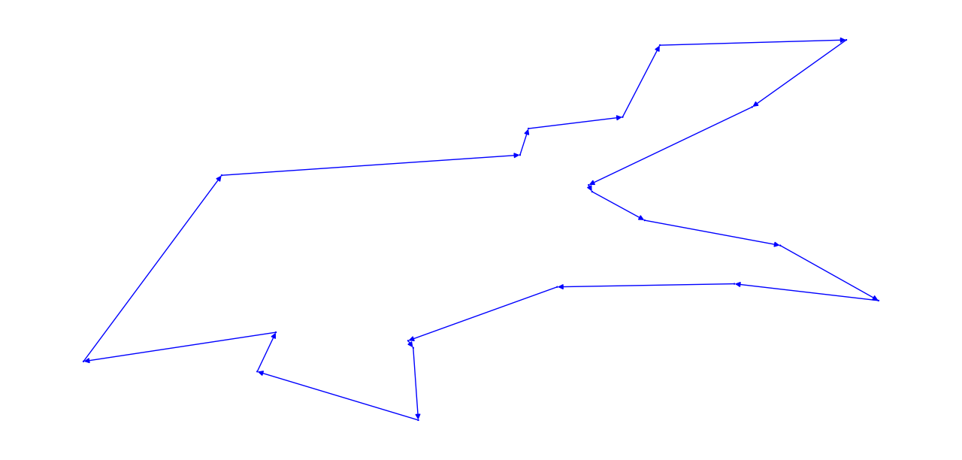

**100Pontos.txt**

[96, 42, 33, 2, 18, 16, 39, 40, 55, 14, 56, 59, 89, 37, 19, 65, 82, 97, 23, 81, 10, 36, 92, 38, 85, 66, 3, 58, 25, 53, 15, 61, 51, 48, 44, 26, 87, 32, 30, 70, 29, 27, 84, 98, 67, 13, 6, 20, 9, 50, 60, 17, 72, 91, 95, 62, 49, 76, 45, 94, 21, 75, 77, 41, 28, 63, 22, 1, 71, 46, 24, 11, 12, 73, 99, 68, 100, 52, 79, 34, 57, 88, 86, 93, 83, 80, 64, 47, 31, 7, 90, 43, 5, 35, 69, 78, 74, 54, 4, 8, 96] = 8278

Tempo = 0.041s

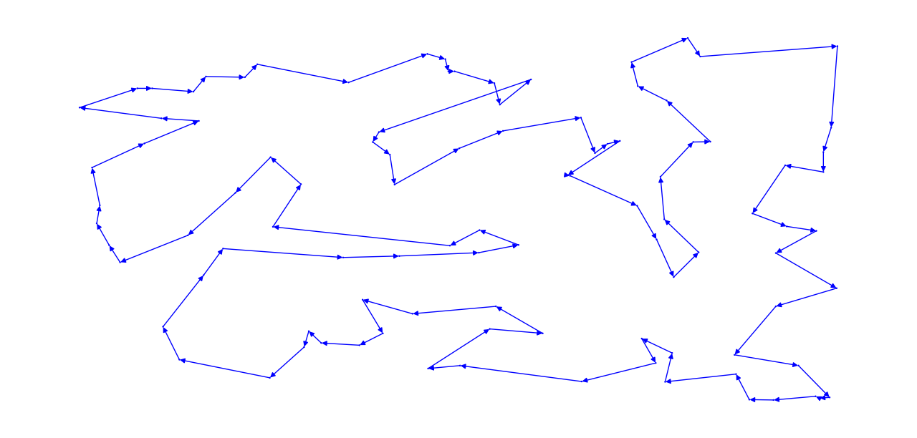

**300Pontos.txt**

[252, 41, 52, 239, 92, 263, 275, 194, 196, 55, 161, 158, 187, 131, 219, 9, 80, 272, 2, 209, 40, 133, 43, 214, 115, 244, 162, 117, 99, 15, 112, 48, 204, 159, 31, 179, 22, 35, 224, 186, 54, 157, 199, 11, 284, 180, 32, 173, 191, 101, 121, 267, 231, 19, 175, 34, 141, 77, 127, 70, 50, 89, 81, 245, 253, 118, 38, 297, 237, 68, 148, 201, 230, 16, 72, 188, 189, 238, 84, 266, 69, 85, 21, 165, 107, 150, 220, 273, 23, 73, 295, 212, 293, 103, 90, 109, 243, 83, 170, 281, 128, 242, 20, 279, 78, 82, 86, 96, 126, 257, 123, 169, 229, 246, 88, 139, 130, 271, 221, 184, 183, 280, 51, 95, 63, 10, 178, 265, 262, 216, 250, 218, 185, 106, 296, 124, 195, 100, 3, 269, 261, 160, 248, 228, 59, 285, 76, 64, 287, 233, 190, 172, 144, 114, 260, 156, 151, 198, 299, 235, 110, 255, 251, 113, 7, 125, 137, 154, 74, 174, 135, 288, 176, 53, 29, 25, 26, 111, 163, 6, 207, 42, 283, 79, 105, 46, 93, 153, 98, 56, 30, 149, 1, 44, 202, 24, 254, 213, 27, 217, 8, 193, 12, 226, 211, 291, 134, 65, 17, 97, 236, 222, 241, 33, 5, 104, 58, 259, 122, 223, 49, 182, 57, 181, 168, 282, 120, 36, 119, 167, 192, 268, 91, 166, 129, 71, 270, 39, 140, 240, 102, 28, 264, 171, 142, 132, 14, 47, 205, 146, 18, 4, 145, 62, 258, 60, 108, 152, 37, 147, 294, 298, 75, 61, 247, 210, 164, 138, 215, 45, 66, 277, 227, 143, 292, 177, 116, 290, 234, 155, 67, 136, 300, 232, 225, 13, 200, 206, 256, 249, 278, 286, 276, 94, 87, 203, 197, 274, 289, 208, 252] = 14263

Tempo = 1.78s

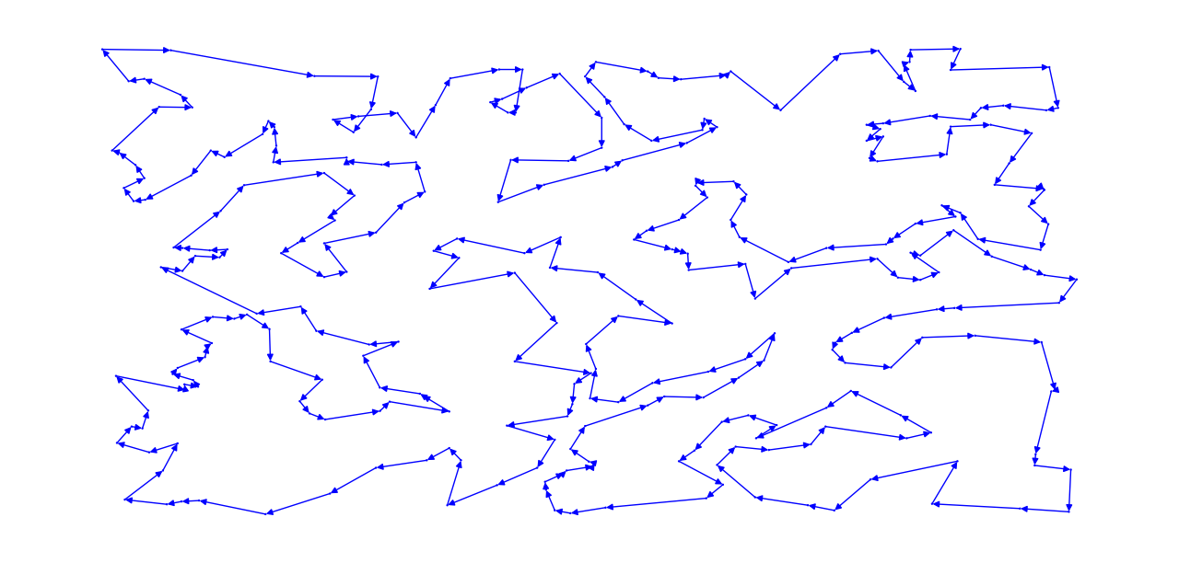

**500Pontos.txt**

[301, 427, 6, 155, 433, 447, 397, 496, 370, 250, 163, 415, 183, 79, 454, 54, 102, 40, 426, 435, 190, 137, 342, 256, 101, 258, 146, 411, 455, 341, 206, 89, 259, 284, 428, 60, 337, 438, 188, 304, 273, 5, 74, 384, 231, 446, 345, 4, 124, 358, 41, 150, 167, 176, 449, 456, 42, 119, 66, 278, 468, 114, 472, 126, 364, 185, 330, 289, 241, 436, 104, 228, 422, 463, 48, 106, 498, 152, 486, 376, 300, 243, 268, 333, 242, 125, 270, 288, 118, 50, 500, 160, 49, 346, 128, 143, 225, 409, 158, 218, 141, 348, 343, 335, 353, 334, 296, 211, 196, 492, 203, 7, 464, 361, 424, 401, 215, 354, 324, 261, 14, 107, 175, 267, 96, 184, 423, 10, 216, 193, 123, 294, 237, 467, 179, 93, 249, 439, 406, 94, 297, 205, 493, 68, 61, 248, 254, 230, 170, 321, 299, 414, 95, 388, 274, 57, 98, 148, 97, 396, 11, 82, 75, 166, 318, 491, 154, 404, 173, 408, 381, 459, 197, 26, 227, 445, 245, 235, 115, 372, 477, 466, 279, 85, 168, 329, 293, 142, 262, 239, 65, 474, 325, 212, 479, 63, 309, 264, 375, 45, 164, 252, 461, 327, 405, 213, 247, 28, 86, 275, 88, 410, 442, 356, 13, 105, 47, 391, 113, 18, 383, 234, 130, 319, 139, 413, 53, 59, 194, 379, 298, 12, 90, 172, 222, 452, 110, 37, 291, 21, 135, 9, 30, 122, 317, 283, 34, 373, 320, 478, 306, 108, 177, 269, 226, 236, 33, 285, 489, 162, 482, 437, 136, 244, 199, 133, 87, 80, 390, 2, 277, 116, 475, 246, 485, 430, 360, 208, 91, 192, 378, 305, 366, 3, 260, 350, 462, 282, 470, 223, 460, 129, 16, 488, 232, 419, 314, 481, 357, 351, 265, 418, 27, 69, 165, 495, 131, 469, 385, 484, 174, 307, 313, 144, 52, 497, 280, 316, 156, 328, 412, 386, 84, 355, 71, 271, 39, 73, 151, 457, 421, 224, 46, 240, 395, 195, 23, 315, 159, 19, 145, 111, 368, 389, 55, 134, 220, 290, 399, 458, 15, 64, 189, 371, 191, 352, 473, 201, 36, 157, 312, 62, 400, 322, 109, 331, 51, 465, 471, 100, 120, 180, 276, 187, 121, 392, 238, 286, 32, 338, 499, 450, 281, 25, 448, 217, 363, 186, 92, 209, 77, 147, 431, 374, 35, 169, 266, 76, 58, 233, 480, 440, 403, 43, 393, 20, 70, 336, 444, 443, 303, 161, 347, 229, 78, 171, 476, 214, 487, 207, 453, 407, 210, 202, 416, 398, 387, 1, 420, 181, 451, 308, 81, 326, 204, 149, 323, 310, 402, 292, 332, 257, 182, 221, 198, 24, 219, 253, 441, 365, 394, 340, 138, 272, 132, 251, 17, 99, 359, 483, 263, 31, 38, 380, 83, 490, 344, 153, 494, 8, 56, 112, 432, 22, 200, 339, 67, 434, 369, 44, 140, 178, 311, 103, 72, 117, 127, 382, 362, 295, 425, 302, 349, 377, 429, 287, 255, 29, 417, 367, 301] = 19072

Tempo = 9.86s

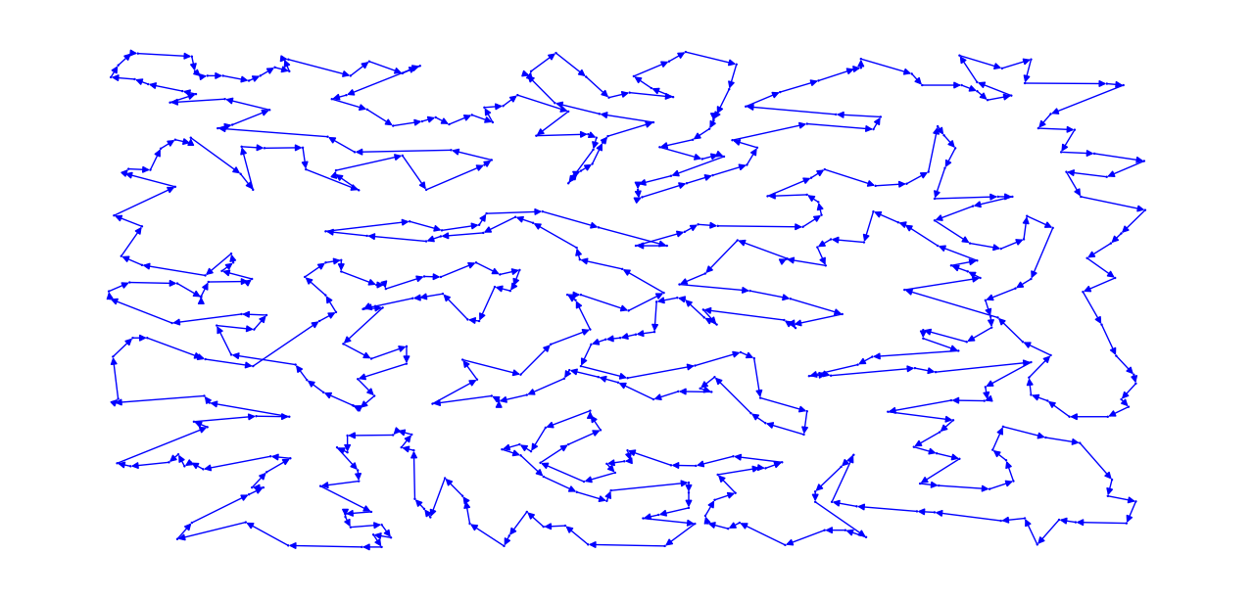

**1000Pontos.txt**

[286, 835, 389, 85, 789, 662, 319, 547, 679, 828, 654, 155, 668, 848, 687, 797, 56, 398, 205, 233, 534, 369, 582, 884, 186, 295, 685, 826, 277, 330, 340, 856, 391, 89, 919, 623, 28, 710, 37, 477, 993, 495, 209, 39, 929, 195, 520, 759, 799, 696, 645, 238, 481, 510, 38, 244, 493, 667, 386, 175, 228, 596, 21, 772, 761, 315, 987, 981, 640, 229, 796, 864, 181, 541, 620, 218, 126, 921, 396, 129, 11, 680, 248, 75, 979, 844, 703, 702, 231, 177, 394, 449, 949, 434, 740, 6, 937, 603, 250, 500, 855, 418, 731, 690, 410, 674, 366, 660, 193, 488, 843, 469, 517, 633, 900, 347, 420, 178, 451, 605, 870, 701, 378, 72, 339, 960, 237, 463, 161, 408, 642, 688, 538, 335, 632, 354, 74, 312, 328, 344, 752, 162, 646, 905, 393, 583, 661, 361, 368, 984, 48, 66, 908, 697, 715, 444, 559, 355, 296, 447, 735, 435, 310, 704, 558, 337, 916, 991, 51, 450, 879, 371, 433, 912, 817, 636, 875, 412, 34, 405, 364, 419, 832, 923, 518, 725, 220, 61, 841, 686, 467, 120, 625, 345, 906, 947, 554, 896, 57, 555, 982, 866, 81, 379, 270, 996, 898, 59, 202, 383, 815, 665, 585, 338, 829, 439, 788, 158, 406, 959, 584, 428, 65, 581, 278, 941, 833, 736, 60, 931, 792, 894, 602, 598, 300, 663, 465, 758, 677, 572, 508, 141, 265, 595, 100, 489, 887, 738, 20, 533, 827, 284, 222, 897, 946, 972, 468, 272, 304, 988, 933, 850, 254, 29, 473, 560, 370, 962, 55, 638, 775, 142, 764, 968, 271, 31, 691, 292, 845, 16, 44, 750, 708, 145, 504, 94, 92, 198, 716, 821, 262, 200, 895, 649, 793, 201, 352, 927, 387, 236, 516, 757, 191, 568, 143, 999, 438, 719, 629, 474, 348, 365, 509, 497, 807, 139, 872, 494, 164, 268, 426, 291, 920, 62, 975, 432, 552, 413, 985, 606, 777, 928, 149, 241, 3, 322, 169, 499, 615, 79, 723, 281, 545, 911, 456, 64, 346, 803, 185, 795, 635, 814, 479, 712, 476, 245, 207, 88, 437, 184, 243, 970, 253, 902, 52, 77, 42, 511, 153, 904, 952, 23, 883, 251, 986, 753, 132, 671, 781, 709, 627, 1000, 548, 681, 454, 609, 836, 357, 955, 258, 837, 104, 963, 224, 969, 515, 823, 199, 675, 616, 739, 492, 71, 631, 45, 275, 599, 650, 297, 26, 748, 822, 87, 301, 586, 760, 834, 151, 637, 594, 747, 694, 720, 914, 978, 360, 930, 196, 453, 421, 289, 825, 791, 722, 880, 293, 922, 441, 423, 461, 762, 18, 82, 577, 446, 404, 320, 232, 206, 766, 14, 774, 892, 303, 751, 800, 246, 411, 112, 266, 440, 501, 863, 282, 147, 257, 744, 342, 587, 331, 279, 2, 176, 382, 264, 742, 285, 655, 49, 138, 53, 659, 226, 617, 187, 128, 743, 997, 35, 839, 954, 592, 925, 998, 325, 189, 693, 223, 8, 359, 607, 871, 644, 417, 707, 950, 172, 212, 159, 819, 964, 327, 851, 17, 597, 801, 484, 308, 350, 689, 780, 730, 873, 227, 116, 756, 373, 714, 890, 542, 375, 374, 522, 765, 367, 711, 882, 192, 225, 811, 403, 101, 995, 269, 656, 431, 773, 732, 399, 54, 818, 695, 98, 551, 852, 648, 684, 869, 401, 570, 36, 309, 575, 610, 363, 111, 526, 4, 763, 240, 593, 234, 96, 830, 470, 769, 442, 445, 885, 754, 106, 527, 180, 7, 536, 152, 768, 392, 210, 260, 944, 436, 397, 455, 109, 9, 983, 351, 961, 812, 721, 480, 86, 612, 565, 782, 647, 940, 385, 221, 657, 324, 878, 776, 283, 150, 15, 529, 168, 868, 472, 358, 329, 135, 122, 422, 622, 125, 288, 953, 215, 591, 311, 194, 783, 332, 90, 576, 22, 531, 429, 188, 886, 24, 938, 561, 860, 27, 482, 556, 154, 102, 523, 235, 567, 989, 160, 847, 958, 992, 816, 134, 692, 123, 261, 513, 32, 263, 119, 794, 95, 779, 384, 464, 99, 80, 68, 290, 889, 771, 219, 611, 859, 746, 40, 589, 909, 590, 626, 809, 165, 30, 713, 108, 569, 448, 230, 808, 179, 458, 737, 733, 842, 47, 496, 862, 613, 813, 211, 136, 83, 314, 994, 10, 672, 208, 334, 907, 167, 786, 512, 718, 546, 858, 505, 903, 425, 804, 380, 252, 103, 566, 717, 724, 503, 854, 918, 41, 356, 144, 415, 316, 43, 452, 58, 381, 948, 971, 664, 140, 91, 682, 653, 564, 336, 571, 619, 25, 666, 133, 678, 966, 214, 50, 727, 183, 608, 424, 107, 770, 562, 110, 507, 910, 549, 124, 1, 831, 683, 932, 302, 148, 734, 579, 530, 407, 247, 242, 728, 980, 767, 942, 857, 113, 475, 706, 137, 343, 670, 705, 76, 741, 267, 525, 276, 945, 926, 13, 203, 614, 491, 127, 951, 588, 487, 498, 956, 749, 471, 524, 372, 19, 726, 676, 838, 805, 630, 846, 745, 84, 798, 502, 973, 849, 755, 557, 259, 131, 430, 943, 901, 466, 362, 197, 326, 574, 402, 255, 157, 460, 899, 317, 539, 321, 414, 618, 130, 965, 213, 156, 785, 537, 485, 146, 166, 977, 390, 550, 395, 876, 924, 217, 216, 490, 521, 305, 967, 73, 443, 543, 624, 63, 528, 578, 287, 643, 323, 802, 580, 115, 540, 93, 333, 535, 874, 673, 239, 462, 729, 913, 778, 990, 416, 634, 306, 939, 78, 790, 519, 934, 173, 935, 349, 249, 824, 658, 699, 70, 478, 298, 891, 105, 641, 46, 457, 974, 861, 544, 121, 486, 377, 881, 604, 388, 182, 936, 806, 163, 651, 957, 256, 174, 313, 784, 917, 698, 514, 976, 573, 787, 628, 67, 274, 700, 915, 409, 669, 427, 553, 532, 400, 865, 299, 353, 867, 5, 652, 601, 307, 639, 171, 69, 97, 563, 294, 853, 459, 840, 318, 170, 280, 877, 893, 341, 114, 118, 273, 810, 888, 190, 506, 117, 204, 483, 376, 621, 600, 12, 33, 820, 286] = 26521

Tempo = 104.02s

